**OUTREACH SCHOOLS EXAMINATION BOARD**

** BEGINNING OF TERM III EXAMINATION 2024**

**PRIMARY ONE**

**LITERACY II**

**My name is ____________________________________________**

**I am in _________________________________________________**

**My school is ___________________________________________**

1. **Fill in the missing sounds to complete the words.**
2. b__ __ k (ii) m___ ___n

(iii) sch__ __l (iv) f___ ___d.

1. **Write words of sound “ee”**

___________________________________________

___________________________________________

___________________________________________

___________________________________________

1. **Write the first sound for these pictures.**

___________________ _______________

_________________ _____________

1. **Circle the correct word from the following words.**
2. skena sanke snake sekna
3. neck ncek nkec kcne
4. trina train tarin rtain
5. **Shade with the correct colour.**

yellow blue

orange green

1. **Arrange these words to form correct sentences.**
2. a teacher She is.

_______________________________________________________

1. will cut you That knife.

_______________________________________________________

1. four nails see I can.

_______________________________________________________

1. **Underline words with sound “sh”.**
2. The big dish is broken.
3. I shall go with Jane.
4. I am going to the shop.
5. Dan has a sharp razorblade
6. **Join and form a word.**

b-a-ll ________________________________

s-me-ll ________________________________

st-i-ll ________________________________

f-i-ll ________________________________

1. **Name these pictures**

This is a ____________________________

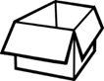

This is a ____________________________

This is a ____________________________

This is a ____________________________

1. **Colour this picture.**

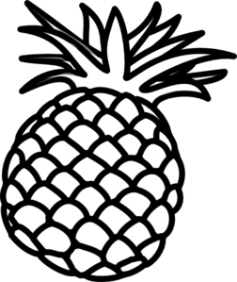

1. **Copy these patterns correctly.**

**Good Luck**